B. I. C. T. E.
A TU affiliated "Bachelor Degree in
Information & Communication Technology

Course Outline & Handbook for
Fourth Semester

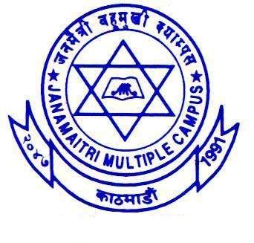

JANAMAITRI MULTIPLE CAMPUS
Kuleshwor Height,
Kathmandu
www.janamaitri.edu.np

Stream:- Education;
Faculty: Information and Communication Technology Education;
Semester: Fourth Semester;
Course Title: B ICTE;

Course Description

# Learning Psychology:
This course is designed to provide students with knowledge and understanding about learning theories and their application in teaching and learning. The course introduces different learning theories – behaviorism, cognitive and constructivism. In addition, the course helps students to draw educational implications of different learning theories.

# Operating System:
This course is focused on to develop knowledge about different concepts of operating systems. This course helps the students to develop both theoretical and practical knowledge about different concepts of operating systems such as basic concepts, process and thread, memory, storage, and I/O concepts related to operating system. This course also helps students to know the different aspects of some popular operating systems.

# Database Management System:
The purpose of this course is to introduce the fundamental concepts of database management, including aspects of data models, database languages, and database design. At the end of this course, a student will be able to understand the fundamental concepts required for the use and design of database management systems.

# System Analysis & Design:
The course is a blend of understanding of system analysis & design with its practical applications. This course includes understanding of various elements of system analysis and design with emphasis on the application of information technology issues as a business tool. The course covers components of system analysis and design techniques, data modeling, logical process modeling, and object oriented modeling techniques.

#Geometry:
This course is designed for prospective secondary level ICT teachers to provide a deeper and broader understanding of different types of geometries .This course deals with axiomatic systems which enables to identify the process that how a geometrical structure is developed. The detail discussion of different types of geometries will help them to have a broader knowledge about geometrical figures and their properties. The replacement of the axioms, postulates and undefined terms together with the related theory will enable them to shift their ideas from one situation to another which empowers their critical thinking and develops their level of confidence. The properties of non-Euclidean geometry and projective geometry will be helpful to see the existence of different kinds of geometries.

# Probability & Statistic:
Statistics helps us to crunch large amount of information into usable numbers. A major reason for the development and regular use of statistics is a need to cope with the limited capacity of human working memory. Statistics aims to condense opinions, performances and comparisons among them into summary numbers that can be understood in a simple way through graph and in more advance way through test of significance where probability has major role

Rules and Regulations
- Students must wear college uniform to enter into college premises, with valid Student’s Identity card.
- Student’s Attendance will be taken and recorded daily and minimum 80% attendance is mandatory.
- Students must bring a leave application from their guardians whenever they are on leave.
- Students who are irregular in classes will be warned and strict action (expel from the
- All students must enter and leave the college on scheduled time.
- Students are obliged to do their Class Work, Home Work and prepare a study note related to the subject regularly.
- Students are obliged to participate in the activities conducted by the faculties and college.
- Any damage caused to the property of JMC must be compensated by the students
- Political activities are strictly prohibited in and around the college premises.

Assignments and Exams;
- There will be 3 assignments to be submitted on each semester (one assignment per months).
- Each semester 2 presentation must be prepared and delivered during the class hours.
- Pre Board Exam will be conducted by the ICTE Central Coordination Committee of Public Campus affiliated with TU.

Lab Work Books/ Project & Field Reports;
- For practical subject, Lab Work Book (In a Prescribe Format) is Compulsory.
- Student's involved in any of the project or field work must submit the Project Report or Field Report (on the prescribed format by the faculty).

